

# DATA MANAGEMENT

Lecturer : Mr. DHASON PADMAKUMAR

**LEARNING OUTCOMES**

At the end of this project, you should be able to:

1. Read, Combine and categorize various forms of data sets.

2. Interpret analytical data models by creating summary reports and enhanced listings.

3. Formulate visualization and discovery strategies.

4. Develop cognitive abilities and non-subject-specific skills in professional report writing and developing clarity of thought

**INSTRUCTION**

Lasiandra Finance Inc. (LFI) New York, USA is a leading private financing company which caters the funding needs of Small and Medium enterprises (SME). LFI clearly understood that some business dreams need that extra push to see them accelerated. Hence it allows its loaning process as tailor-made and customer centric. In the past few years, it has tremendously expanded its wings and to speed up the process, it needs to automate the loan eligibility process based on customer portfolio entered online.

**PROBLEM**

The main problem faced by the LFI is the approval process of the loans. Because it is a complicated procedure of verification and validation but still there is no guarantee whether the chosen applicant is the deserving one out of all applicants. Hence, it needs a model which can predict the loan approval.

**TASK**

You are the recent hire as one of the Data Scientist at the Headquarters of LFI, Washington, D.C., United States. You have been assigned to analyze the data set obtained from the past customers, and build a most accurate model to predict the approval process as approved or rejected. Your department chief hands over this assignment to you with the work flow as shown in Figure 1.

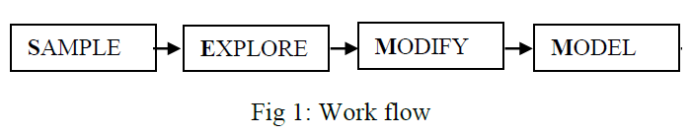

You are required to follow the work flow and to build the model proposed. Report the output produced by the model you found, out of your analytical study to the management of LFI.

The variables on the dataset are as follows:

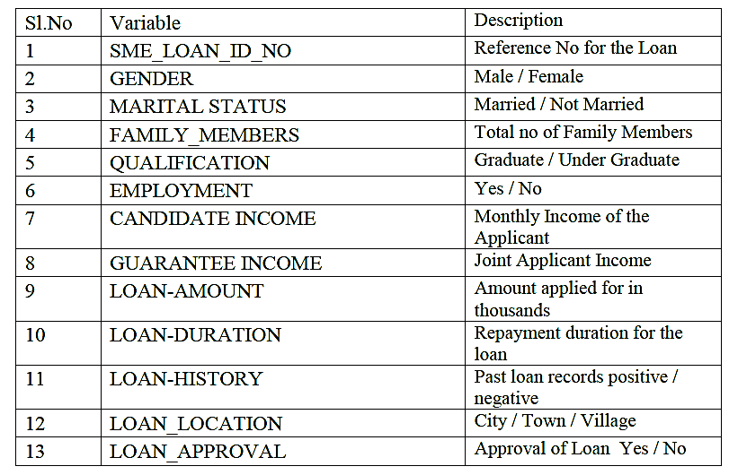

**DELIVERABLES & FULFILLMENT**

1) You are required to conduct a thorough analysis on the dataset by writing programs with SAS.

2) The report requires you to introduce the data, methods and coding problems that precipitated your interest in this study. You should also discuss your ultimate goal and objective when undertaking this analysis.

3) Produce output results, interpret them and write a report and/or presentation using the outputs.

**PROGRAM DEMONSTRATION & CODING**

Be sure to break down complicated procedures into their essential steps, and to demonstrate the steps with sub sets of PROC, SQL code, macro code or supplementary code. At each step, explain whether the code worked the way you anticipated. Identify areas of improvement and next steps. Discuss obstacles and don't worry about including mistakes. It’s also perfectly reasonable to come up against a seemingly intractable programming problem, or one that threatens to overtake much of your effort on the project, and make some

modifications to the project. Often these modifications involve a change in your goal, possibly by simplifying code and output. Be straightforward and honest about these obstacles in your write-up.

At the end of the process, you should have a complete set of code that you demonstrate on your full data set, along with the product of the code, data sets or tables, ODS (Output Delivery System) output, etc. Be sure to write a conclusion summarizing your project and reflecting on what you learned. Include suggestions for improvement or enhancements to your final product, and discuss their feasibility. Useful comments also help describing the intent of each step in the program.